EAM: Emergency Access Management
VIRSA 4.0 ------> Fire Fighter (FF)
GRC AC 5.1, 5.2, 5.3 ------- > Super user Privilege Management (SPM)
GRC AC 10, 10.1,12 -------> EAM
Background of this Concept:
- 70% of the Authorizations assigned to users were never used.
- Within the Authorization used by user, 15 – 20% of the Authorizations are rarely used.
T-codes have been categorized as below.
- Daily used – Assigned to user on permanent basis
Ex, SU01, PFCG, SU10, PFUD, and SUIM…...
- Rarely used = Critical – this access would be assigned only when required and requested by user (30% T-codes) Ex, SU25, SU24, SU20, SU21

When critical access is needed,
Requested --- > User
Approved ---- > Approver – FF ID/FF Role - Owner
Granted (linking)---- > Security/GRC
Usage of FFID/FF role ------ > User
Monitored --- > Monitor ---- > FF ID/FF Role Controller

Granting is done in 2 ways.
- ID based
- Role based

Firefighter Concept based on granting/providing access:
ID based
Normal user id will be linked to FF ID (which has critical Access assigned) for short duration – 1 to 5 days.
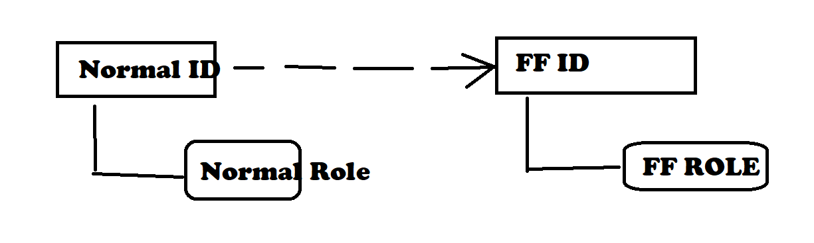
Role Based
FF role will be assigned to Normal user based on the request and for short duration - 1 to 5 days.
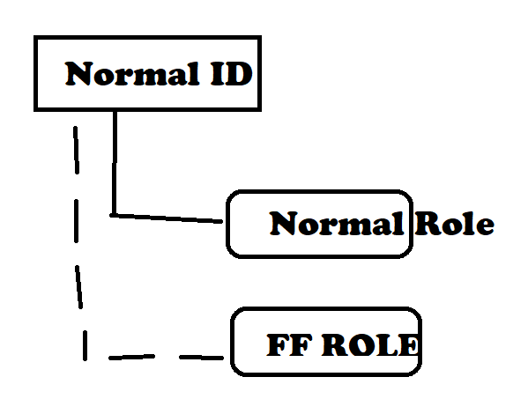

ID Based FF Concept:
To use Critical T-codes assigned to user through FF ID, user must launch the EAM Launch Pad /FF Launch Pad
This can be launched in 2 ways.
- GRC system ------- > Centralized FF ID Concept
- Plug in system (S4HANA/ECC/BW) ------- > Decentralized FF ID Concept
FF ID Concept based on Login:
- Centralized FF - Login from GRC system – GRAC_SPM or GRAC_EAM (T-codes)
- Decentralized FF – Login from Plug In system and execute T-code /n/GRCPI/GRIA_EAM
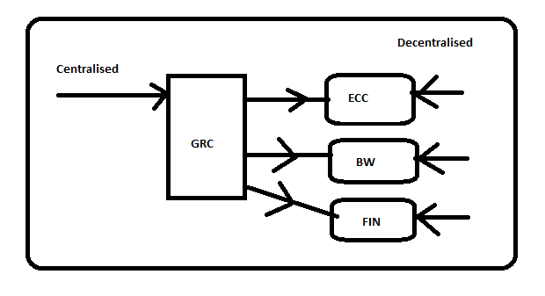

Possible concepts in EAM:
1. ID Based (Launch pad Concept)
- Centralised FF Concept (User should exist in GRC)
- Decentralised FF Concept (User should exist in Plug in system)
2. Role Based (No Launch pad Concept)

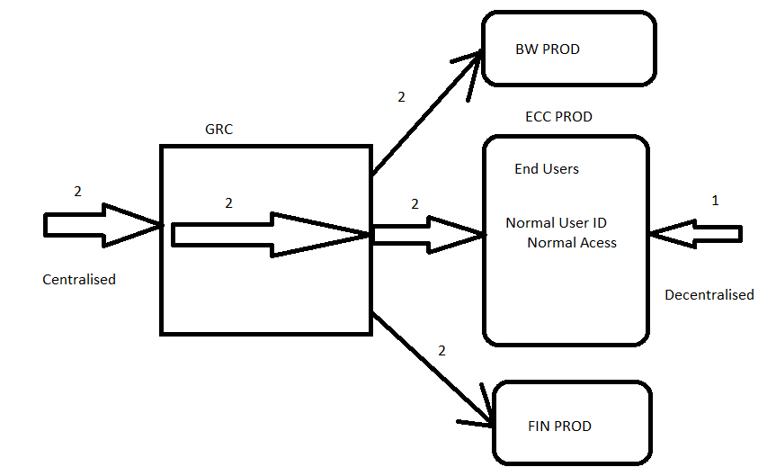
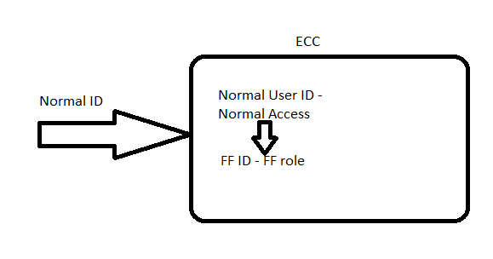
 | GRC | Plug In (ECC)
Centralized FF ID Based | Owner, Controller, FF | FF, FF ID
Decentralized FF ID Based | Owner, Controller | FF, FFID
Role Based | Owner, Controller | FF, FF Role
What is FF ID?
- Special ID assigned with FF Role -Critical T-codes
- Exist in Plug-In Systems – ECC/S4HANA/BW…..
- FF IDs are used by non-business users/Technical Users

Non-Business users/Technical Users Ex, Sec, ABAP, BASIS, SAP FI, SAP SD, SAP MM etc.
Business users Ex, Create PO, Approve PO

Give some examples/scenarios where FF ID is used?
1. Security team --- > Upgrade SU25
2. BASIS team ---- > Client Opening SCC4
3. ABAP team ---- > Debug the PROG SE38
4. Finance team ---- > Master Data Set up – Vendor/Customer Master data
5. MM team ---- >
6. SD team ----- >
Centralized- ID based firefighting concept set up:
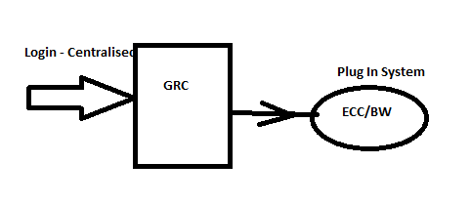
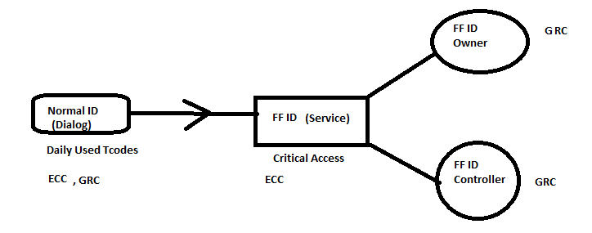
- We need the following ids as mentioned below
GRC system – FF, FF ID Owner, FF ID Controller
Plug in System (S4HANA/ECC) – FF, FF ID
ID Based:
- Firefighter – Normal User (dialog) or person who uses FF ID.
GRC System - Launch Pad T-code access - GRAC_EAM or GRAC_SPM
Role Name: SAP_GRAC_SUPER_USER_MGMT_USER
Plug In System – Access to daily operations
- FF ID – Special id which is of Service User Type assigned with critical access (FF ROLE) and SAP_GRAC_SPM_FFID: Role that must be assigned to every FF ID
- FF ID Owner – Person who approves FF ID (FF Role) access to user and responsible for assigning FF ID to normal user
SAP_GRAC_SUPER_USER_MGMT_OWNER

- FF ID Controller – person who monitors/reviews the activity done by user (FF) using the FF ID
SAP_GRAC_SUPER_USER_MGMT_CNTLR

- Define /Declare FF ID Owner and FF ID Controller in the Set Up ---- > Access Control Owners link. (Not required in GRC 12 since it embedded in 3rd step)
NWBC ------> Set Up ----- > Access Owners

- Mapping FF ID Owner and FF ID controller to the FF ID
NWBC ---- > Set Up ---- > Emergency Access Assignment ------ > Owners.
NWBC ---- > Set Up ---- > Emergency Access Maintenance ------ > Controllers
- Define Reason Codes
NWBC ---- > Set Up ---- > Super User Maintenance ------ > Reason Codes
Raising FF ID requests and FF ID Linking with Normal User is done in 2 ways.
- Manually - Approval and Linking
- Automated – Workflow - ARM

- Linking FF ID with FF (normal user id)
NWBC ---- > Set Up ---- > Emergency Access Assignment ------ >FF IDs
Or
NWBC ---- > Set Up ---- > Emergency Access Maintenance ------ > Firefighters
FF Logs:
Path: NWBC --→ Reports & Analytics ---- > EAM reports ----- > FF log Report
FF logs will be reviewed by the controller.

Time based FF ID Log: GRAC_EAM_LOG_SYNC_TIMEBASED
Timestamp: 20.231.130.010.101 (YYYYMMDDHHMMSS)
20260510010101 to 20260511230101
20250405010101 to 20250405230101
20230918220101 to 20240918220101
Note:
New t-code GRAC_FFSESSION to replace above program
https://community.sap.com/t5/financial-management-blogs-by-sap/firefighter-session-maintenance-grac-ffsession/ba-p/13580608

In VIRSA 4.0 and GRC 5.1, 5.2, 5.3 (1990 – 2010) ---- > DECENTRALISED Concept
In GRC 10 SP01 to SP09 (2011) ------> CENTRALISED concept
In GRC 10 SP10 and above (2012) --- > CENTRALISED & DECENTRALISED concept

De-Centralised ID Based Firefighting Concept:
- 4015 parameter – enable it - YES.
- Create all required users in
GRC ---- > FFID Owner and FFID Controller
ECC system ---- > FF, FFID
Ensure FF has access to Launch Pad T-code: /n/GRCPI/GRIA_EAM in Plug in System (Role: SAP_GRIA_SUPER_USER_MGMT_USER)
- Mapping FF ID Owner and FF ID controller to the FF ID
NWBC ---- > Set Up ---- > Super User Assignment ------ > Owners
NWBC ---- > Set Up ---- > Super User Maintenance ------ > Controllers
- Define Reason Codes
NWBC ---- > Set Up ---- > Super User Maintenance ------ > Reason Codes

- Linking FF ID with FF (normal user id)
NWBC ---- > Set Up ---- > Super User Assignment ------ >FF IDs
Or
NWBC ---- > Set Up ---- > Super User Maintenance ------ > Firefighters.

- Additional Config in Plug In(ECC/BW) system:
Local RFC must be created
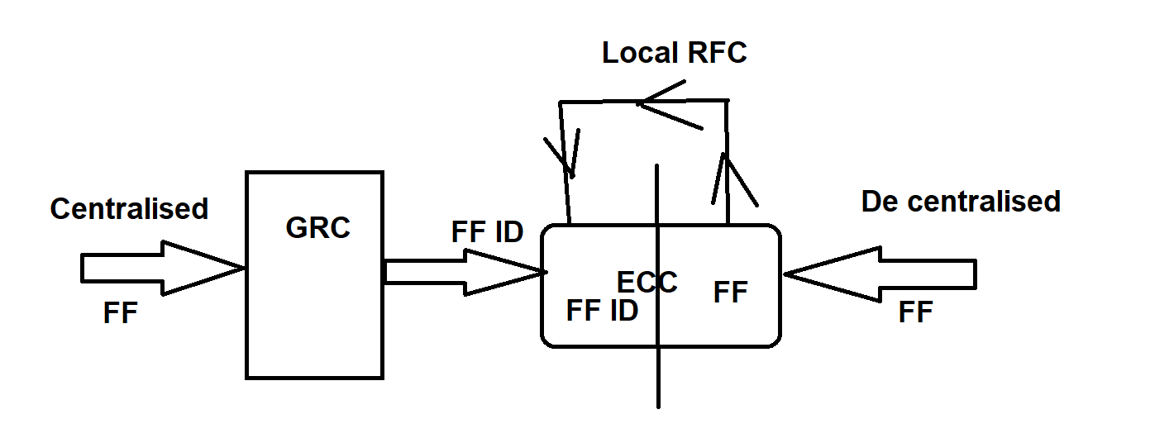

SPRO --- > GRC (Plug-In) ----- > Access Control ---- > Maintain Plug-In Configuration Settings

1000 Parameter – Maintain Local RFC Name pointing to same system and it is like your Connector name between GRC and Plug in System.

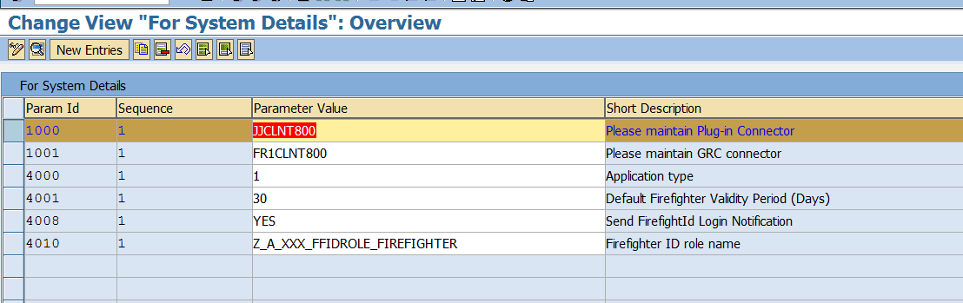

- Sync Job – EAM_MASTER_DATA_SYNCH – run this job for only for De-centralised Concept.

Role based Firefighting Concept:
- Define 4000 Parameter with value 2 – Role based.
- Role must be created in BRM with setting ENABLE for FIRE FIGHTING

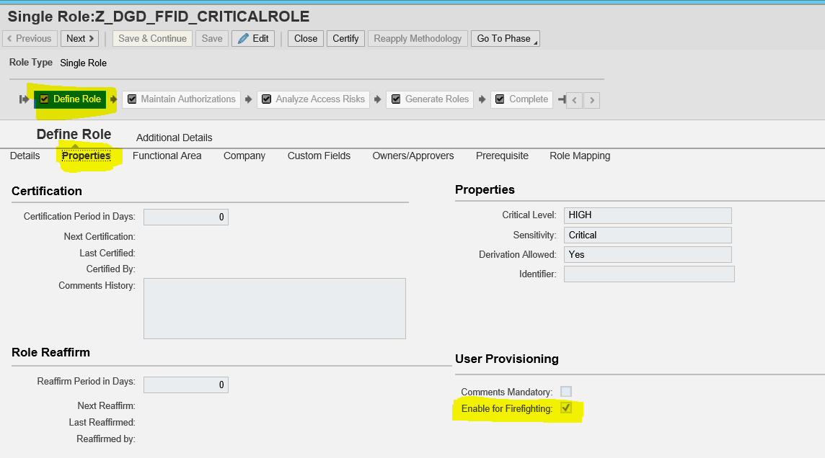

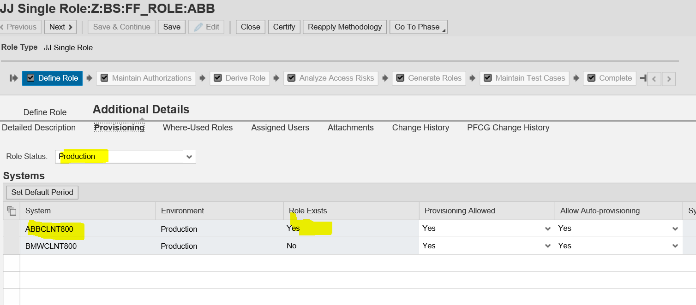

- Ensure user ids are existing for FF ROLE OWNER and FF ROLE CONTROLLER.
- Declare them under SET UP --- > Access Control Owners (Not required in GRC 12)
- Mapping of FF ROLE with FF ROLE OWNER and FF ROLE CONTROLLER
- Linking FF ROLE to the FF (Normal User)
- User can login into ECC and perform the Firefighting Concept

If the FF ID is not visible in GRC system what could be the Reasons?
- 4010 Parameter role - SAP_GRAC_SPM_FFID is not assigned to FF ID
- Repository Sync job is not run after creating FF ID and assigning the above role
ZSAP_GRAC_SPM_FFID: Role that must be assigned to every FF ID.
Whichever role is mentioned in parameter 4010, that role must be assigned to every FF ID in plug in systems. If this is custom role, that should be copy of SAP_GRAC_SPM_FFID

Imp parameters related to EAM:
4000 Series is related to EAM/FF
4010: FF ID role - SAP_GRAC_SPM_FFID (Identifier Role – Which ever user id is assigned with this role, that ID is considered as FF ID in GRC system)
4000: ID based or Role based
4001: Default Firefighter Validity Period (Days)
4015: Activate Decentralized
Note: 4015 Parameter was launched from SP10 in GRC 10 and above. Earlier than that, only centralized concept was available by default.

Disadvantages of Role Based:
- Users are confused or not conscious about using the FF role.

GRC Centralized (ID Based)
***********************
User1 ---- > GRC GRAC_SPM/EAM -----> Logon Pad ----> ECC New Screen (FFID)

Decentralized - ECC (ID Based)
***************************
User1 -----> ECC /n/GRCPI/GRIA_EAM ------> Logon Pad ----> ECC New Screen (FFID)

Role Based
***************************
User1 -----> ECC GUI ----> Same Screen User1(FF_ROLE)

Disadvantages of ID Based: (fixable)
- Sequence of steps in a t-code or internal calling of t-codes
EX, LSMW
Initial Steps – Create Project (recording) ---- > Not critical --- > Assign to NORMAL ID
Later Steps – Execute project ---- > Critical ----- > Assign to FF ID

or

SM30/SE16 (Table: TCDCOUPLES)

SM30 (Edit Table) + SE16 ---- > FF ID
SE16 (Display Table) ------> Normal ID

Disadvantages of Centralized FF concept:
- All the users who ever want to use FF ID in Plug in systems, they should also exist in GRC system – Additional Maintenance for Security/GRC team.
- Users who do not exist in Plug-in system (ECC)and if they exist in GRC system, they can use the FF ID in the Plug-in system (ECC)

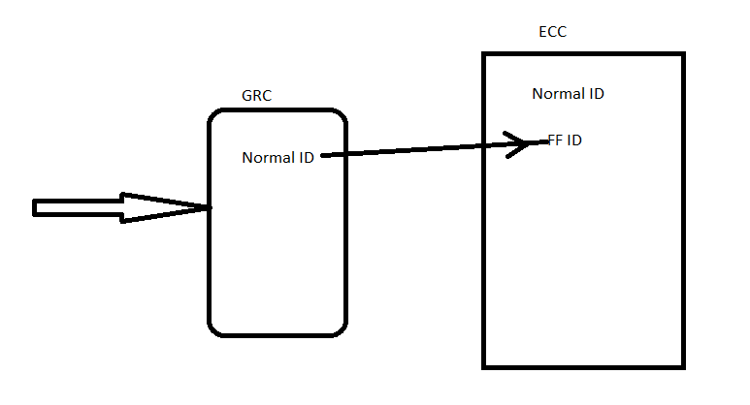
Usage:
Decentralized >>> Centralized >>> Role based

Real time:
BASIS Team (10)
- FFID_OS_BS1 -- > OS related T-codes
- FFID_DB_BS1 --- > DB related T-codes

- FFID_BASIS1 --- > BASIS FF role
- FFID_BASIS2 --- > BASIS FF role
- FFID_BASIS3 --- > BASIS FF role

Finance Team
- FFID_FIN1
- FFID_FIN2
- FFID_FIN3

Some Clients have dedicated FFID to every user in the Org. Any changes in PROD system should be done by FF ID
- U1: FFID_U1 --- > One year
- U2: FFID_U2
- U3: FFID_U3
SAP_ALL should not be assigned to FF ID?
(Daily used t-codes should not be assigned to FF ID)
- There is no use in creating separate FF ID team wise. Segregation (SOD) is not possible.
- Unnecessary logs will be generated, and it is difficult for the Controller to monitor. He will lose interest in reviewing the logs.

Advantages of FF concept:
- Tracking the usage of critical T-Codes
- Minimize the total Access risk count in the organization – Risk Analysis

Disadvantages of EAM:
1. Not possible with JAVA/ABAP Web Dynpro based systems Ex, CRM, SOLMAN, PI-PO, EP, FIORI
2. Time based FF ID access cannot be granted (ER Emergency Repair -Security Weaver – Mins based)
FF LOGS:
NWBC ---- > Reports & Analytics ------ > EAM Reports
- FF log Summary Report

Try this: Assignment
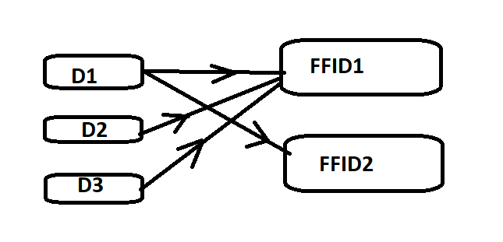

New Features in GRC 12 for EAM:
- No need to maintain EAM approvers in Access Control Owners Link
- EAM concept can be used in HANA Database level – HANA DB – We have concept of Privileges (T-codes). It will record privileges.
Ex,, System privilege ---- > User Admin – Create User, Modify User, Delete User
System privilege ---- > System Admin ---- >

Example:

ECC/S4HANA - Month end period opening - Finance IT team

ABB_FI_USER1
Normal Role --- > FB01, FB02, FB03

FF ID --- > FF role
OB52 --- > Critical t-code

ABB_FI_USER1 ---- > FF ID Access

Centralized FF ID concept
#########################

1.ABB_FI_USER1 login into GRC system
2.Launch the EAM /FF Launch pad - GRAC_EAM/GRAC_SPM
3.Login into ECC through FF ID -- > ABB_FI_FFID1
4.Then execute OB52 and open the period
5.Log out of FF ID

